Cable Modem

📺 What is a Cable Modem?
# Source: Chatgpt (GPT‑5 Mini) at [12/18/2025]
A Cable Modem is a device that provides internet access over cable TV lines (coaxial cables). It connects your home or business to your Internet Service Provider (ISP) via the cable TV infrastructure, using a standard called DOCSIS (Data Over Cable Service Interface Specification).

🔧 What Does a Cable Modem Do?
# Source: Chatgpt (GPT‑5 Mini) at [12/18/2025]
- Modulates digital signals from your computer/router into analog signals for transmission over cable lines.
- Demodulates incoming analog signals from your ISP into digital data.
- Acts as the gateway between your local network and the internet.

🖥️ Cable Internet Setup Example
# Source: Chatgpt (GPT‑5 Mini) at [12/18/2025]
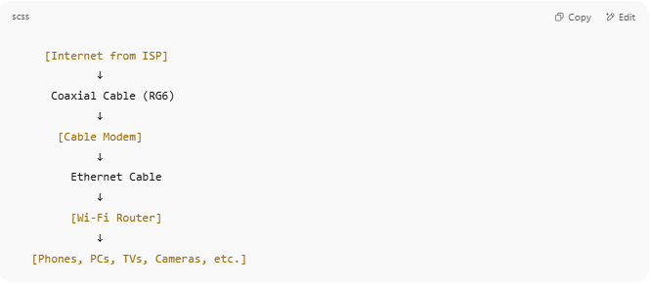

[Internet from ISP]
↓
Coaxial Cable (RG6)
↓
[Cable Modem]
↓
Ethernet Cable
↓
[Wi-Fi Router]
↓
[Phones, PCs, TVs, Cameras, etc.]

💡 Some devices combine the modem and router into a modem/router combo.

📶 Key Features of a Cable Modem
# Source: Chatgpt (GPT‑5 Mini) at [12/18/2025]
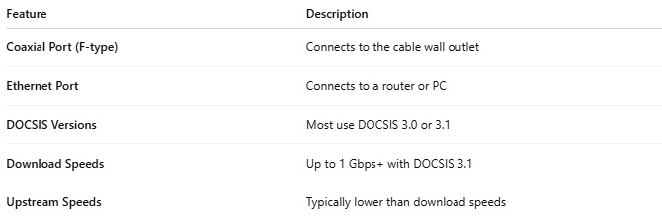

Feature | Description
Coaxial Port (F-type) | Connects to the cable wall outlet
Ethernet Port | Connects to a router or PC
DOCSIS Versions | Most use DOCSIS 3.0 or 3.1
Download Speeds | Up to 1 Gbps+ with DOCSIS 3.1
Upstream Speeds | Typically lower than download speeds

📊 DOCSIS Versions Compared
# Source: Chatgpt (GPT‑5 Mini) at [12/18/2025]
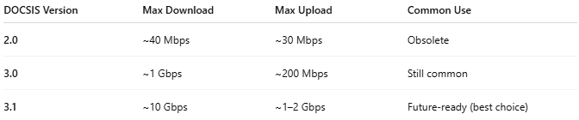

DOCSIS Version | Max Download | Max Upload | Common Use
2.0 | ~40 Mbps | ~30 Mbps | Obsolete
3.0 | ~1 Gbps | ~200 Mbps | Still common
3.1 | ~10 Gbps | ~1–2 Gbps | Future-ready (best choice)
📌 DOCSIS 3.1 is recommended for gigabit plans.

🆚 Cable Modem vs DSL Modem
# Source: Chatgpt (GPT‑5 Mini) at [12/18/2025]
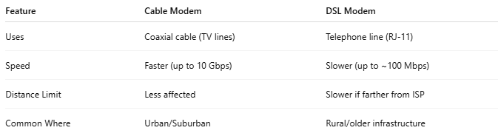

Feature | Cable Modem | DSL Modem
Uses | Coaxial cable (TV lines) | Telephone line (RJ-11)
Speed | Faster (up to 10 Gbps) | Slower (up to ~100 Mbps)
Distance Limit | Less affected | Slower if farther from ISP
Common Where | Urban/Suburban | Rural/older infrastructure

✅ Pros
# Source: Chatgpt (GPT‑5 Mini) at [12/18/2025]
- ✅ High download speeds
- ✅ Widely available in urban areas
- ✅ Supports streaming, gaming, smart homes
- ✅ Works with most major ISPs (like Xfinity, Spectrum)

❌ Cons
# Source: Chatgpt (GPT‑5 Mini) at [12/18/2025]
- ❌ Bandwidth shared with neighbors (slower at peak times)
- ❌ Needs a separate router for Wi-Fi (unless it's a combo unit)

